User Manual for Helpdesk Portal
Website URL: https://astarhelp.zendesk.com/hc/en-us

- Users can look through the articles in the below categories to self-help first before logging a helpdesk ticket. Alternatively, key words can be keyed in the search bar as well to facilitate the search.
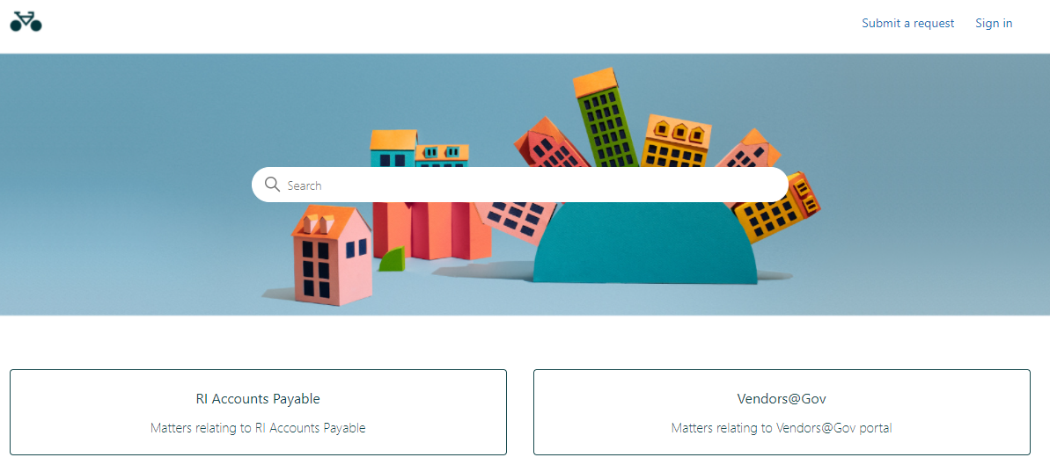
Categories

- If user is still unable to locate the required information from the articles in the Help Centre, user can proceed to log a helpdesk ticket:

- Please select the correct category below before submitting your request:
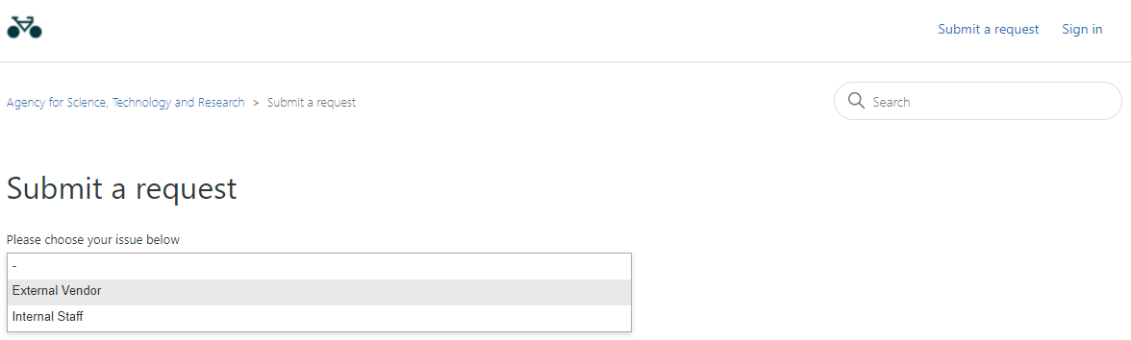

- Please fill in the fields with the relevant information:
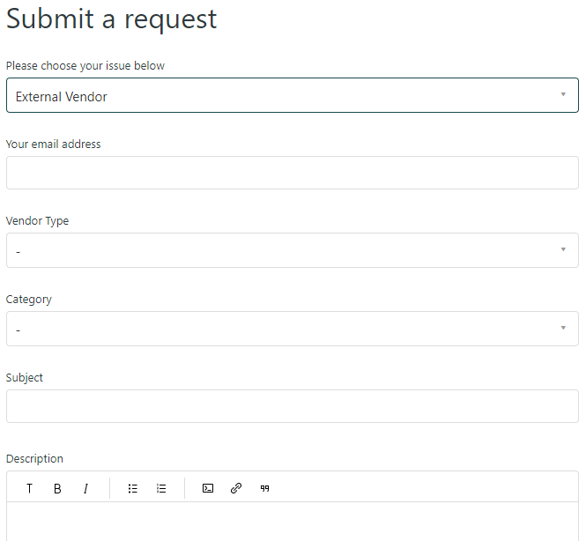
C. Select the category that best fits the nature of your query
A. Indicate the email address with which you wish to receive updates on your query
B. Select if you are a ‘Singapore Vendor’ or ‘Foreign Vendor’
D. Input the subject line for your query Best to include key words of your query
E. Elaborate on your query. You may attach relevant links/documents to this portion

- You will receive an email notification upon successful submission of your query.
- Our agents managing the helpdesk will attend to your query within 5 working days. You may reply to the email notification indicated in point (5) if you wish to add on more information/updates to your query.
- Please note not to amend the email subject of your query in any manner and use the email notification for any follow-ups on the query.

